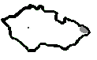

KARVINA DISTRICT FACT SHEETS
bus connections updated on March 2012

Direct bus connections to Karvina
From | No. of inhabitants* | Arrival  6 AM - 2 PM | Arrival  2 PM - 10 PM | Arrival  10 PM - 6 AM
Ostrava | 303 609 | 14 | 15 | 4
Orlova | 32 067 | 28 | 18 | 7
Bohumin | 22 631 | 7 | 4 | 2
Cesky Tesin | 25 445 | 25 | 17 | 7
Havirov | 82 022 | 30 | 18 | 7
*1st January 2011

Bus connections from the center of Karvina to bus station Nove Pole
Bus No. | 6 AM - 2 PM | 2 PM - 10 PM | 10 PM - 6 AM
514 | 7 | 7 | 1
515 | 2 | 1 | 2
518 | 2 | 2 | 2
Total | 11 | 10 | 5

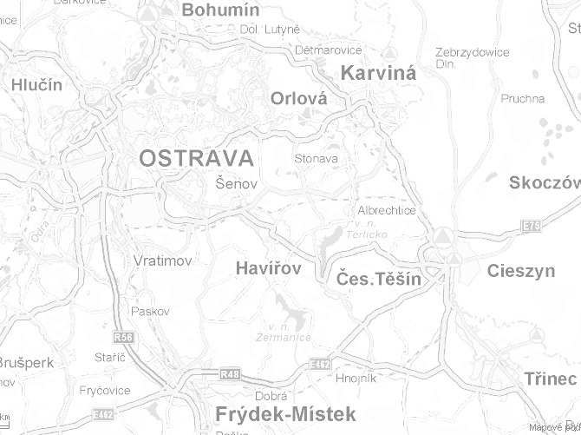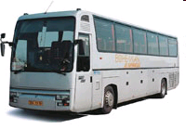

Commuting time by bus:
15 min – 74 000
30 min – 280 000
60 min – 600 000
90 min – 700 000
30 min
60 min
90 min
Public transport system
around Karvina
- Orlova 20 min
- Havirov 30 min
- Cesky Tesin 30 min
- Ostrava 60 min
- Frydek-Mistek 90 min

